JUnit Basic Testing Exercises

Exercise 1: Setting Up JUnit

<dependencies>
<dependency>
<groupId>junit</groupId>
<artifactId>junit</artifactId>
<version>4.13.2</version>
<scope>test</scope>
</dependency>
</dependencies>

Exercise 3: Assertions In JUnit

import static org.junit.Assert.*; import org.junit.Test;
public class MyTest { @Test
public void testAssertions() { assertEquals(5, 2 + 3);
assertTrue(5 > 3);
assertFalse(5 < 3); assertNull(null); assertNotNull(new Object());
}
}

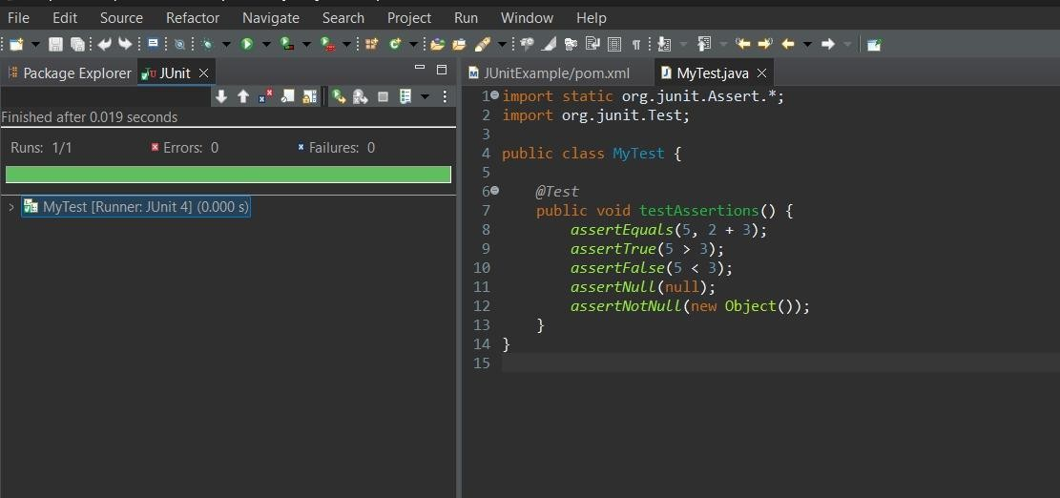

Exercise 4: Arrange-Act-Assert (AAA) Pattern, Test Fixtures, Setup and Teardown Methods in JUnit

Calculator.java
public class Calculator { public int add(int a, int b) {
return a + b;
}
public int multiply(int a, int b) { return a * b;
}
}

CalculatorTest.java
import static org.junit.Assert.*;

import org.junit.Before; import org.junit.After; import org.junit.Test;
public class CalculatorTest { private Calculator calc; @Before
public void setUp() {
calc = new Calculator(); System.out.println("Setup done");
}
@After
public void tearDown() { calc = null;
System.out.println("Teardown done");
}
@Test
public void testAdd() {
int result = calc.add(2, 3); assertEquals(5, result);
}
@Test
public void testMultiply() {
int result = calc.multiply(3, 4); assertEquals(12, result);
}
}

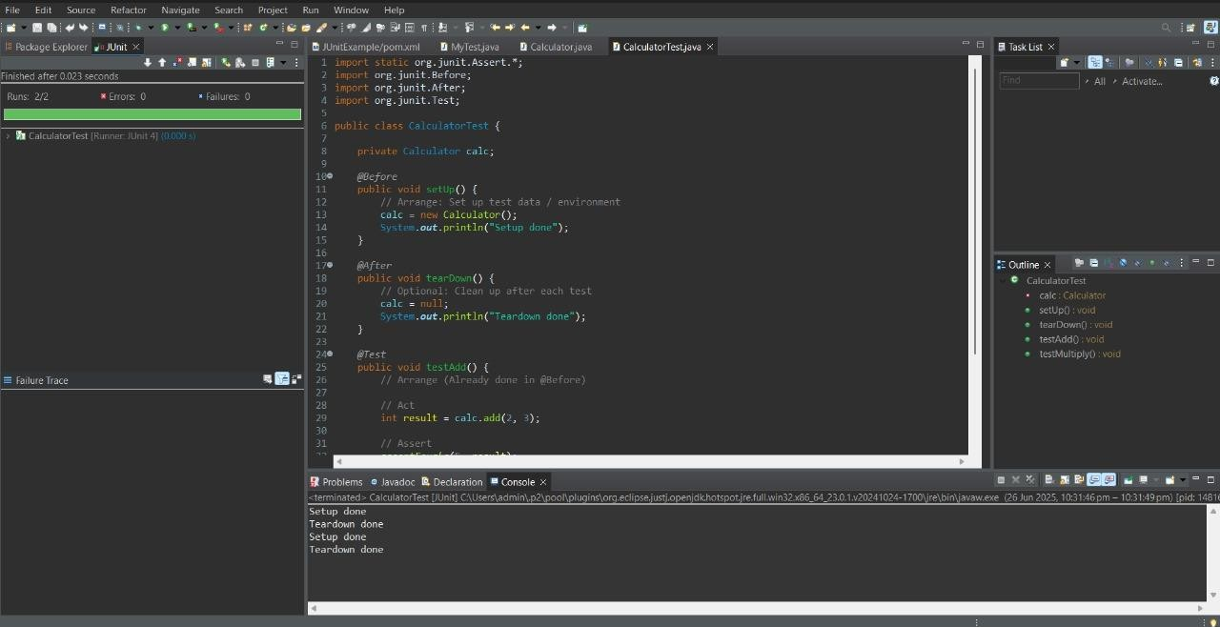

Mockito Exercises

Exercise 1: Mocking and Stubbing

MyServiceTest.java
package mockitotest;
import static org.mockito.Mockito.*;
import static org.junit.jupiter.api.Assertions.*; import org.junit.jupiter.api.Test;
import org.mockito.Mockito; public class MyServiceTest {
@Test
public void testExternalApi() {
ExternalApi mockApi = Mockito.mock(ExternalApi.class); when(mockApi.getData()).thenReturn("Mock Data"); MyService service = new MyService(mockApi);

String result = service.fetchData(); assertEquals("Mock Data", result);
}
}

ExternalApi.java package mockitotest; public class ExternalApi {
public String getData() { return "Real Data";
}
}

MyService.java package mockitotest; public class MyService {
private ExternalApi api;
public MyService(ExternalApi api) { this.api = api;
}
public String fetchData() { return api.getData();
}
}

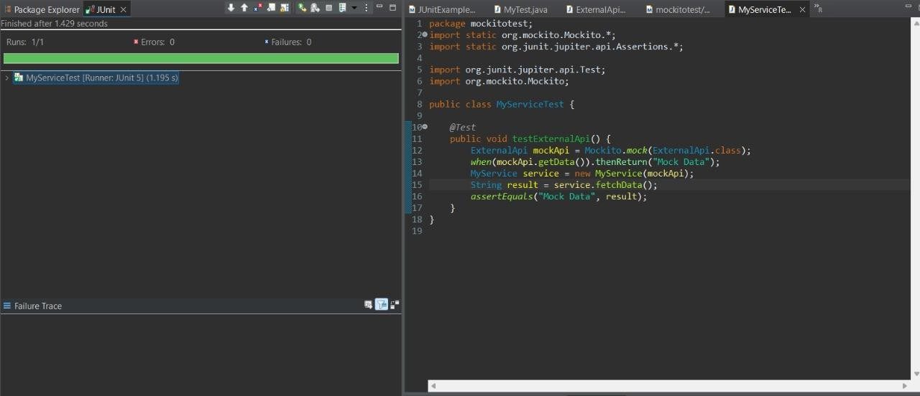

Exercise 2: Verifying Interactions

package mockitotest;
import static org.mockito.Mockito.*;
import static org.junit.jupiter.api.Assertions.*; import org.junit.jupiter.api.Test;
import org.mockito.Mockito; public class MyServiceTest {
@Test
public void testExternalApi() {
ExternalApi mockApi = Mockito.mock(ExternalApi.class); when(mockApi.getData()).thenReturn("Mock Data"); MyService service = new MyService(mockApi);
String result = service.fetchData(); assertEquals("Mock Data", result);
}

//Verifying Interactions

@Test
public void testVerifyInteraction() {
ExternalApi mockApi = Mockito.mock(ExternalApi.class); MyService service = new MyService(mockApi); service.fetchData();
verify(mockApi).getData();
}
}

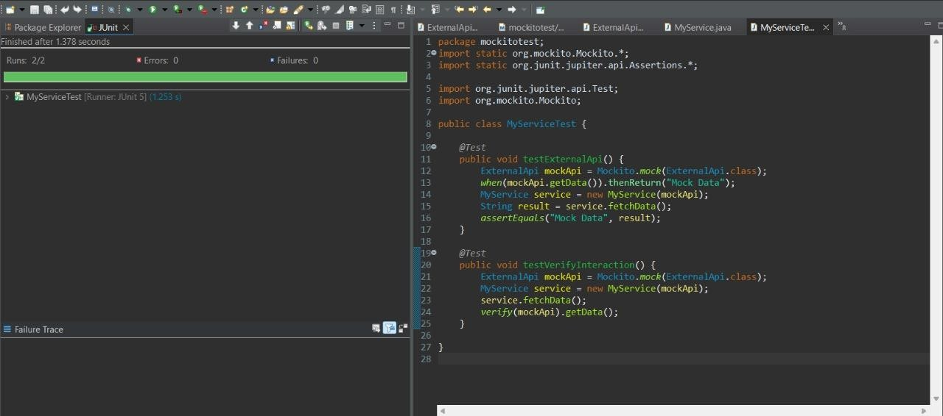
SL4J Logging exercises

Exercise 1: Logging Error Messages and Warning Levels

<dependencies>
<dependency>
<groupId>org.slf4j</groupId>
<artifactId>slf4j-api</artifactId>

<version>1.7.30</version>
</dependency>
<dependency>
<groupId>ch.qos.logback</groupId>
<artifactId>logback-classic</artifactId>
<version>1.2.3</version>
</dependency>
</dependencies>

LoggingExample.java
import org.slf4j.Logger;
import org.slf4j.LoggerFactory; public class LoggingExample {
private static final Logger logger = LoggerFactory.getLogger(LoggingExample.class); public static void main(String[] args) {
logger.error("This is an error message"); logger.warn("This is a warning message");
}
}

